- What is the Varna?_____________________________________________________________
- Which Hindu god is known as the Destroyer?_______________________________________________
- According to the Hindus, _______________________ means that every action has an effect and there is a cause for everything.
- Samsara, the endless cycle of birth, death, and rebirth, is also known as_____________________
- What were the Vedas?_________________________________________
- Who is the Founder of Hinduism?_______________________________________________
- The name 'Hindu' comes from what Sanskrit word_______________.
- Which Hindu god is known as the Creator?_______________________________________________
- What is Moksha? ______________________________________________________
- What is the Holy Place of Hinduism?________________________________________________.
- What is the name and occupation of those at the top of the caste system?_________________________
- Ashrama means what? _____________________________________________________
- What division of Hinduism has a concern for life is extended to all creatures, even minute microbes that are not visible? ________________________
14. Who was Siddhartha Gautama?
15. What religion was Siddhartha in his early years?
16. What did Siddhartha Gautama notice about life that made him begin to ask questions about human life?
17. How did Siddhartha try to free his mind from the daily concerns?
18. Siddhartha determined that human suffering comes from 3 things. What are those three things?
19. What was Siddhartha called after he reached enlightenment?
20. What are the Four Noble Truths?
21. What is the Eightfold Path?
22. What is nirvana?
23. How did the Buddha feel about the caste system?
24. Why did Buddhism spread so quickly?
25. How is Buddhism similar to Hinduism?
26. How is Buddhism different from Hinduism?
Confucianism 2-Purpose
27. Concerned primarily with restoring social _______________________ and _____________________.
28. What is the basis of a stable, unified, and enduring social order? ______________________________.
29. Confucius taught that rulers should lead by example, and this was the only way a truly great empire could be created at last.
30. A system of social and ethical philosophy- IT IS ________________________________________
31. Kami is a general term for Shinto ___________________________ and spirits. Some kami are
32.compared to the “_________________” of the west, but are different in many ways, too. Kami can . also be forces of ____________________, important _________________________, or even natural ________________________. A special rock, a large tree, or a waterfall, can be considered Kami. The ___________________________of __________________________was considered a Kami.
33.Unlike most other religions of the world, Shintoism has NO: Identifiable _____________________, Body of religious laws, written scriptures or ________________________. It does have a very loosely organized ____________________. When entering a shrine, one passes through a Torii . The Torii marks the separation between the finite ____________________and the infinite world of the_____________________________.
1) Label the following on the map below WITHOUT looking at any other maps.
Countries: China, India, Indonesia, Japan, North Korea, South Korea, and Vietnam
Physical Locations: Ganges River, Huang He (Yellow River), Indus River, Mekong River, Yangzte (Chang Jiang) River, Bay of Bengal, Indian Ocean, Sea of Japan, South China Sea, Yellow Sea, Gobi Desert, Taklimakan Desert, Himalayan Mountains, and Korean Peninsula.

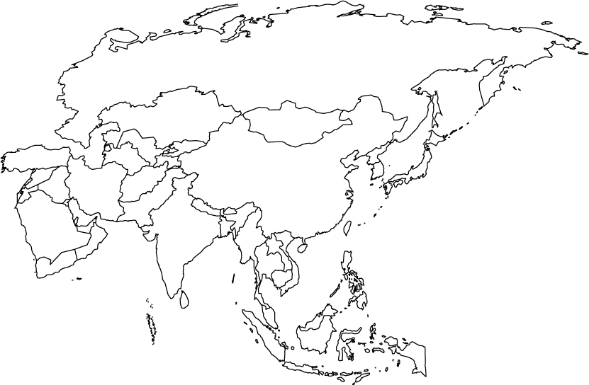
2) Describe the causes and effects of pollution on the Yangtze River.
3) Describe the causes and effects of pollution on the Ganges River.
4) Describe the causes and effects of air pollution and flooding in China.
5) Describe the causes and effects of air pollution and flooding in India.

